

**Report on**

**Institute Searcher**

**Group Members:**

•**Jayant Singh Jhala**

(20CS002272)

•**Nitesh Agrawal**

(20CS002278)

**SUPERVISED BY:**

**Dr. Amit Jain**

Assistant Professor

(School of Engineering)

**Table of Context**

|  |  |  |
| --- | --- | --- |
| **SR.No.** | **Name Of Topic** | **Page No.** |
| **1** | Acknowledgement | 4 |
| **2** | Introduction | 5 |
| **3** | Abstract | 5 |
| **4** | Proposed System | 6 |
| **5** | Hardware Requirements | 6 |
| **6** | Software Requirements | 6 |
| **7** | Flowchart | 7 |
| **8.** | Project Attributes | 8 |
| **9.** | ERD Diagram | 8 |
| **10.** | Program Screenshots | 9-11 |
| **11.** | Sample Output | 12-13 |
| **12.** | Literature | 14 |
| **13.** | Python Usefulness | 15 |
| **14.** | MySQL Usefulness | 17 |
| **15.** | Conclusion | 21 |
| **16.** | Declaration | 22 |
| **17.** | References | 23 |

**Acknowledgement**

We have immense pleasure in presenting the report for our project entitled “Institute Searcher”.

We would like to take this opportunity to express our gratitude to a number of people who have been sources of help & encouragement during the course of this project.

We are very grateful and indebted to our project guide Dr. Amit Jain & our respected HOD Dr. Mukesh Kalla for providing their enduring patience, guidance & invaluable suggestions. They were the one who never let our morale down & always supported us through our thick & thin. They were the constant source of inspiration for us & took utmost interest in our project.

We would also like to thank all the staff members for their invaluable co-operation & permitting us to work in the computer lab.

We are also thankful to all the students for giving us their useful advice & immense co-operation. Their support made the working of this project very pleasant.

**Group Members:**

1.Jayant Singh Jhala

2.Nitesh Agrawal

**Introduction**

It is undoubtedly true that college education is an investment, whereby the student together with their parent spent money, time and energy for years with the intention that this ‘intellectual’ investment would be profitable. Therefore, the people take huge interest in knowing where the top institutes stack up in comparison to the other Institutes, therefore making the Institute ranking useful to many people. Thereby, there are various software to choose from, most of which are hard to navigate and with ton of confusing and irrelevant data. Whereas, our software serves with as basic as possible navigation options made available in one single system and it is based on Python and MySQL.

**Abstract**

The Goal of our project as initially set by us, was making the Institute ranking useful to people those who are searching for various top institute options in India.

Thereby, Cutting the need of hectic Systems available, most of which are hard to navigate and with ton of confusing and irrelevant data.

We have Developed our software to serve with as basic as possible navigation options made available in one single system.

**Proposed System**

providing user with ability to search through various top institutions in India. Ample amount of search options available. Scores, their rankings etc. that are obtained by the ranking process of Institutions according to the National Institution Ranking. Collection, analysis of data and Feed that data into a pre-structured database. Easy to redraft programming framework.

**Hardware Requirements**

**MINIMUM**

64bit x64 CPU

4 Gigabytes RAM

1024x76 Display

**RECOMMENDED**

Multicore 64bit x64 CPU

8 Gigabytes RAM

1920x1200 Display

**Software Requirement**

* Windows 7 or Later (64-bit)
* Python 3.9(Recommended)
* MySQL 8.0.28 or Later

**Flow Chart**

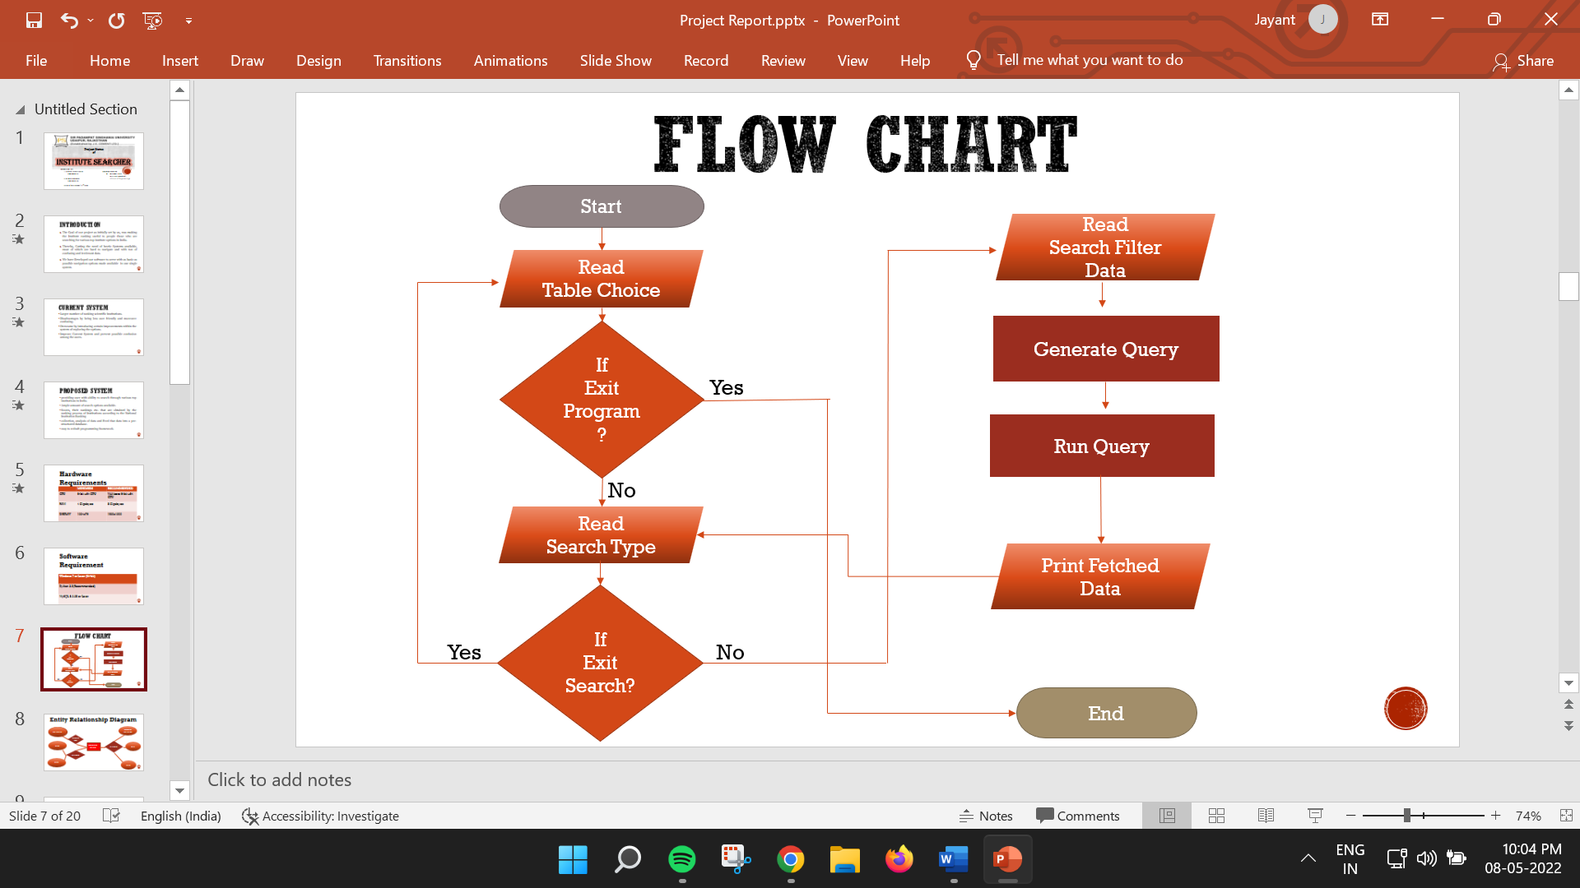

**Project Attributes**

**Institute Searcher Parameters**

* Institute ID • Score
* Name Of Institution • Rank
* City
* State

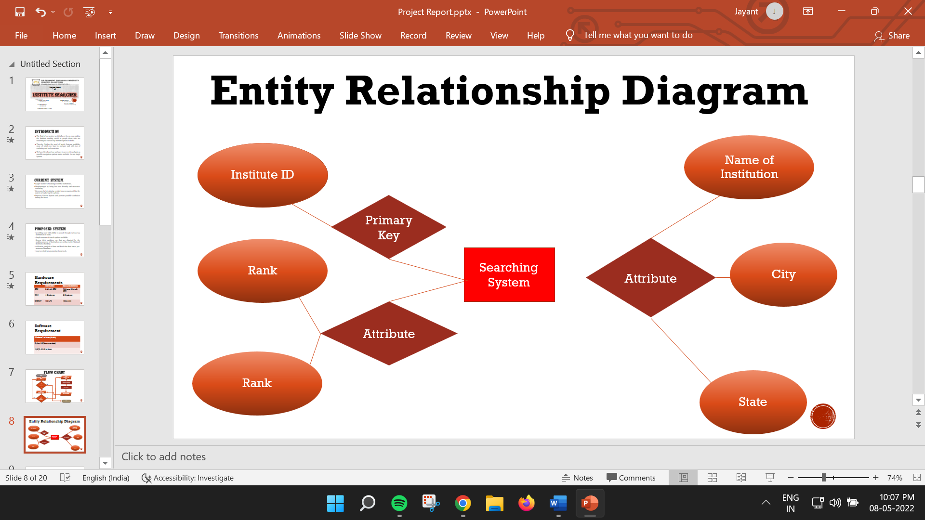**Entity Relationship Diagram**

**Program Screenshot**

**Creating Tables**

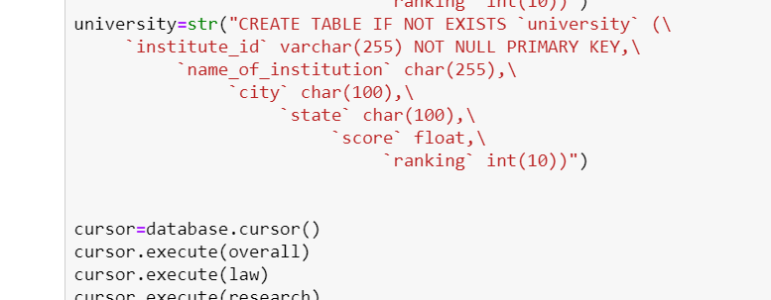

**Transferring Data to Relation**

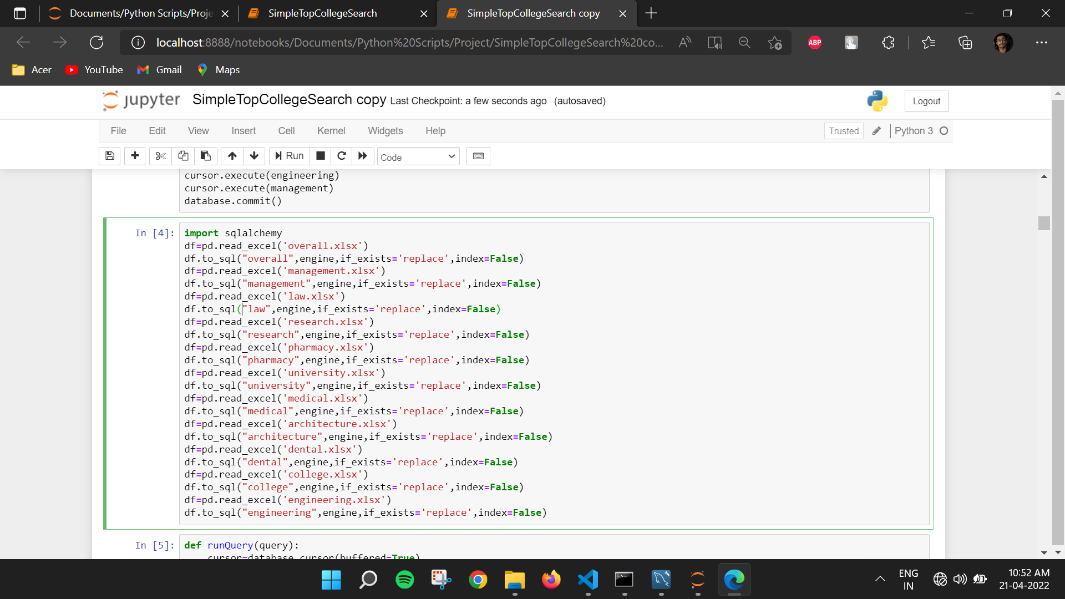

**Main Menu Program**

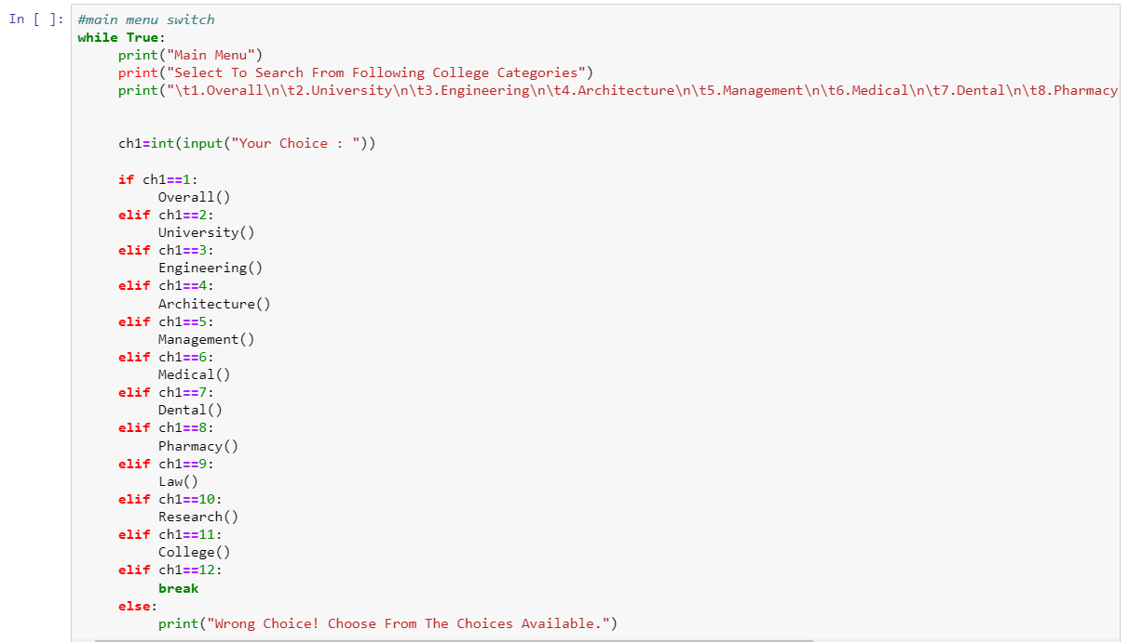

**Specific Field Function**

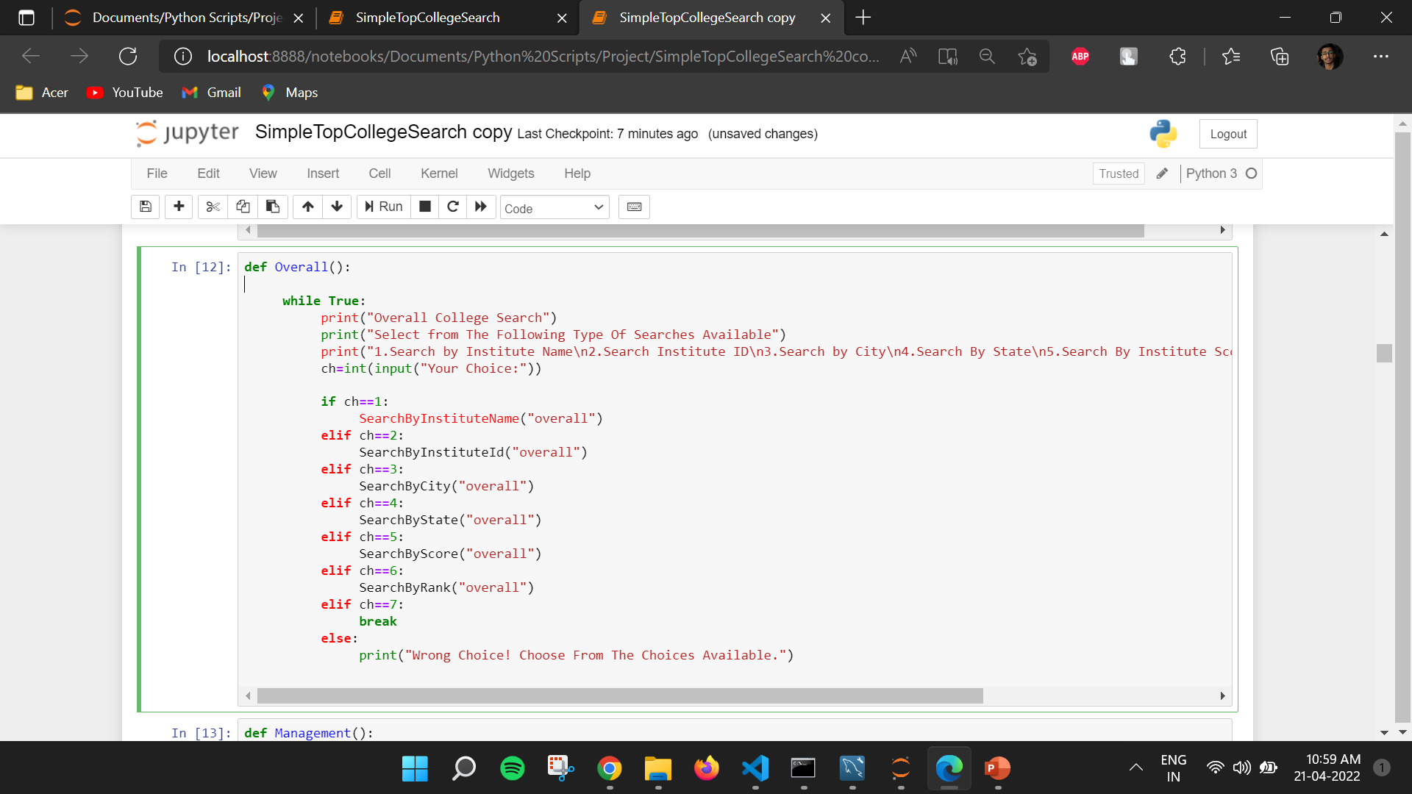

**Type of Search Function**

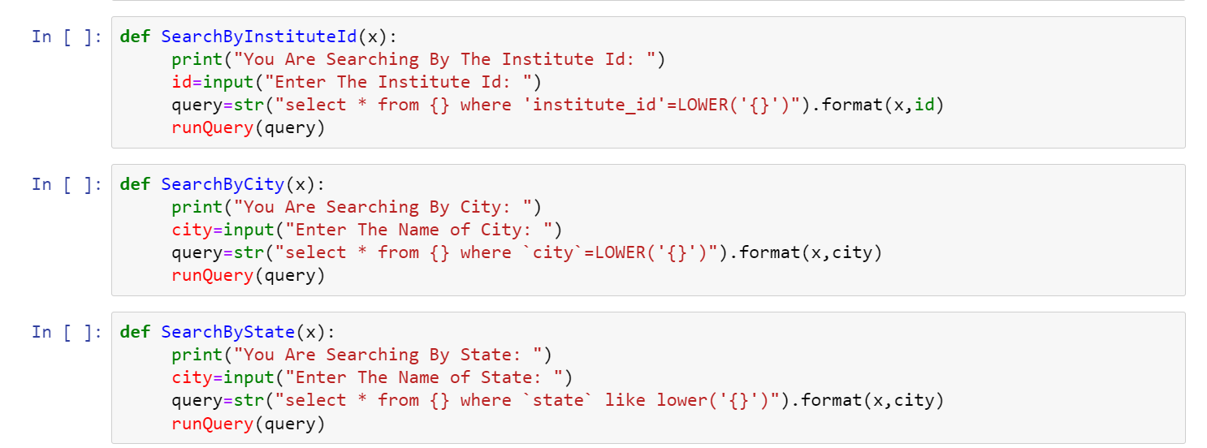

**Running Generated Query**

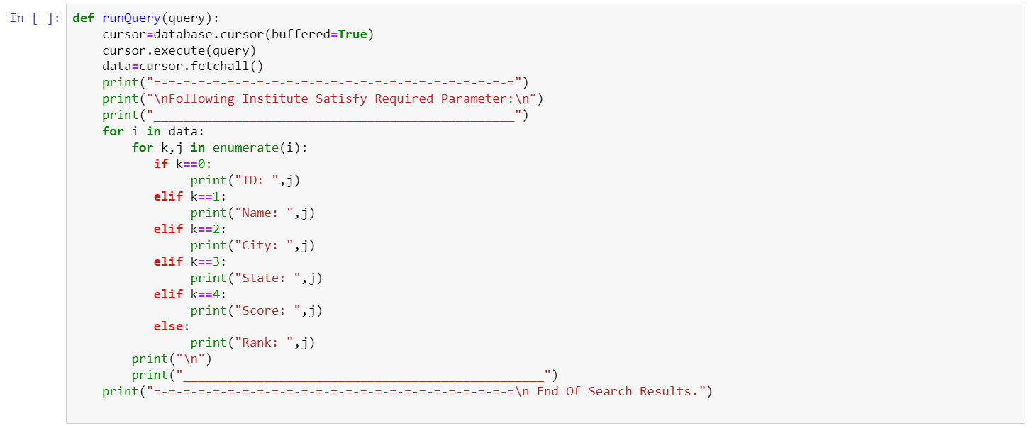

**Sample Output**

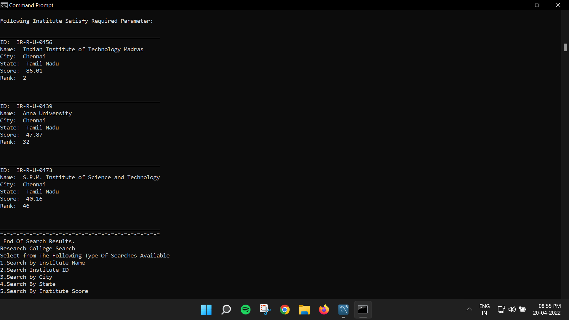



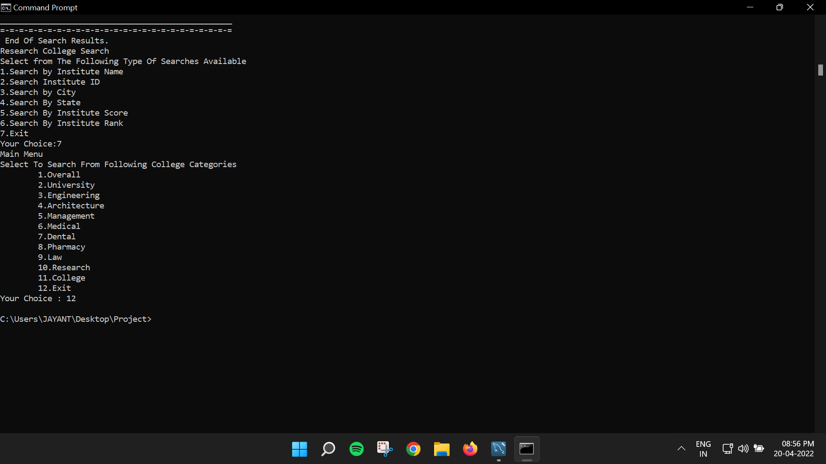

**Literature**

During the past several decades, “ranking system” became an important factor of the way to measure people’s success or failure in India.

As people know, institute searching can provide more information to student and their parents. Also, institution searching make students be able to consider their future Institute based on the facts they need. Those data of institution rankings are collected by trustable survey agencies, independent third parties, or Government agencies such as NIRF. Therefore, the resources of the based information are trustworthy.

Various rankings mostly evaluating on institutional output by research. Some rankings evaluate institutions within the country, while others assess institutions worldwide. The subject has produced much debate about institute exploration’s usefulness and accuracy.

Institution Searching helps students, parents, and education industry organizations who are looking for details on the higher education sector in India. It provides relevant information about courses, ranking of different Institutes, admission procedure for different courses and much more. To help students who give various competitive exams like NEET, JEE Main etc. to select the best colleges.

**Python: The user-friendly language for coding**

Computers, today, come with immense disk space, multi-core processors and high-speed Internet connectivity. And they use computer languages that interact with the operating system and execute processes at a high speed. One such language is Python, which is used as a high-level programming language. It was first released in 1991 by Guido van Rossum, an ex-employee of Google. It is quite easy to learn, as it uses English keywords frequently, unlike the heavy syntaxes of other languages. Moreover, programmers can code the logic using fewer lines of code than what is required in other programming languages like C or Java. The unique design, notably, using white space indentation to delimit code blocks, makes Python more readable and cleaner.

Python is an interpreted, interactive and object-oriented scripting language. The Python code is processed by the processor at run time, i.e., it does not need to be compiled as in Java, which is compiled to get the .class file. The term interactive implies that you can use the Python prompt to write the code, which interacts with the interpreter, and by encapsulating the code within objects, it follows the OOPS principle. The other features that make Python cool are that it is

extendable, i.e., it can run on a wide range of hardware with the same user interface; it is scalable, supporting very large programs; and it has user interfaces for UNIX, Windows and Mac. It also has efficient high-level data structures and extensive standards-free libraries, which make programming easy; hence, it is considered the language for beginners.

In this article, we will learn how to install, set up and use Python. The cool thing about learning Python is that there are no prerequisites. Even if you are a novice to programming you can become a pro coder within a month. To start with, download and install Python*.*

For this article, we are using Python 2.7. The above link also contains Python for Windows and Mac. On most Linux boxes, Python is pre-installed. For Windows, download Python and run the .msi file. Upon completion, add the environment variable named ‘PYTHON’ and its value as the directory where Python is (in this case,’C:\Python27′), as shown in Figure 1. We can verify whether Python has been installed correctly by running the*python – version* command in the command line. This will give you the current version of Python running on your computer, as shown in Figure 2. To create Python files, use any text editor of your choice. For this article, we will be using the Sublime text editor.

**MySQL Usefulness**

MySQL is a free-to-use, open-source database that facilitates effective management of databases by connecting them to the software. It is a stable, reliable and powerful solution with advanced features like the following:

## **1.    Data Security**

MySQL is globally renowned for being the most secure and reliable database management system used in popular web applications like WordPress, Drupal, Joomla, Facebook and Twitter. The data security and support for transactional processing that accompany the recent version of MySQL, can greatly benefit any business especially if it is an eCommerce business that involves frequent money transfers.

## **2.    On-Demand Scalability**

MySQL offers unmatched scalability to facilitate the management of deeply embedded apps using a smaller footprint even in massive warehouses that stack terabytes of data. On-demand flexibility is the star feature of MySQL. This open-source solution allows complete customization to eCommerce businesses with unique database server requirements.

## **3.    High Performance**

MySQL features a distinct storage-engine framework that facilitates system administrators to configure the MySQL database server for a flawless performance. Whether it is an eCommerce website that receives a million queries every single day or a high-speed transactional processing system, MySQL is designed to meet even the most demanding applications while ensuring optimum speed, full-text indexes and unique memory caches for enhanced performance.

## **4.    Round-The-Clock Uptime**

MySQL comes with the assurance of 24X7 uptime and offers a wide range of high availability solutions like specialized cluster servers and master/slave replication configurations.

## **5.    Comprehensive Transactional Support**

MySQL tops the list of robust transactional database engines available on the market. With features like complete atomic, consistent, isolated, durable transaction support, multi-version transaction support, and unrestricted row-level locking, it is the go-to solution for full data integrity. It guarantees instant deadlock identification through server-enforced referential integrity.

## **6.    Complete Workflow Control**

With the average download and installation time being less than 30 minutes, MySQL means usability from day one. Whether your platform is Linux, Microsoft, Macintosh or UNIX, MySQL is a comprehensive solution with self-management features that automate everything from space expansion and configuration to data design and database administration.

## **7.    Reduced Total Cost of Ownership**

By migrating current database apps to MySQL, enterprises are enjoying significant cost savings on new projects. The dependability and ease of management that accompany MySQL save your troubleshooting time which is otherwise wasted in fixing downtime issues and performance problems.

## **8.    The Flexibility of Open Source**

All the fears and worries that arise in an open-source solution can be brought to an end with My SQL’s round-the-clock support and enterprise indemnification. The secure processing and trusted software of MySQL combine to provide effective transactions for large volume projects. It makes maintenance, debugging and upgrades fast and easy while enhancing the end-user experience.

## **Improving MySQL Performance: 3 Tips**

Today almost every open-source web app employs MySQL because it is compatible with all hosting providers and is extremely easy to use. But if your eCommerce website or web application performs poorly, here’s what you need to do:

### **1.    Performance Tuning**

Fine tune your HAProxy instances to improve the performance of your web application. Optimize your database and speed up your server with an advanced load balancing software. A database load balancing software is designed to deliver the agility and scalability needed to expand capabilities and meet both unplanned and anticipated performance demands.

### **2.    Security Audits**

DoS attacks and spamming can wreak havoc on your database server. You can easily prevent performance issues and increase uptime with a robust load balancing software that ensures automatic failover and security updates.

### **3.    Optimizing Queries**

When websites and applications are poorly coded, no database optimization tools and techniques will come in handy when fixing the server load. SQL server load balancing software is a one-stop solution for maintaining uptime, data consistency, increasing performance, reducing service costs, and ensuring continuous availability for an enhanced customer experience. It does everything from running health checks and maintaining high performance to lowering the query wait time and enabling even distribution of load across multiple servers.

**Conclusion**

This project assists in Modifying the existing manual system. This is a paperless work which can be monitored and controlled remotely. It reduces the man power required and provides accurate information. Latest gathered information can be saved, Upgraded and can be accessed at any time. Therefore, the data stored in the Database helps in taking decision by management. So, it is better to have an Institution Searcher System.

**DECLARATION BY THE CANDIDATE**

I the undersigned solemnly declare that the project report Institute Searcher) is based on my own work carried out during the course of

our study under the supervision of Dr. Amit Jain.

I assert the statements made and conclusions drawn are an

outcome of my research work. I further certify that

I. The work contained in the report is original and has been

done by me under the general supervision of our

supervisor.

II. The work has not been submitted to any other Institution

for any other degree/diploma/certificate in this university

or any other University of India or abroad.

III. We have followed the guidelines provided by the

university in writing the report.

IV. Whenever we have used materials (data, theoretical

analysis, and text) from other sources, we have given due

credit to them in the text of the report and giving them

details in the references.

Jayant Singh Jhala(20CS002272)

Nitesh Agrawal(20CS002278)

**References**

* <https://www.nirfindia.org/2021/Ranking.html>
* <https://www.geeksforgeeks.org/>
* <https://www.javatpoint.com/>
* <https://github.com/>